Website Review / Thoughts for Consideration
- Much better design than the original – looks sleek and clean which makes it easy to navigate. Prefer the new look because it’s professional and attractive and moves away from something that attempts to look futuristic and robotic. The old version looks more like something from a videogame.
- “Forged in the C-suite” section of the home page:
  - Will the companies always be grayed out? Will the logos be colored in at some point?
  - Is the measurement bar for the number of CEOs a necessary feature on this page? Would this be better placed on the “100 CEOs” page?
- Clarity, Speed, Value boxes on the home page:
  - Should they each be a separate color (at the top of the box)? Two are the same color currently and one is a different color.
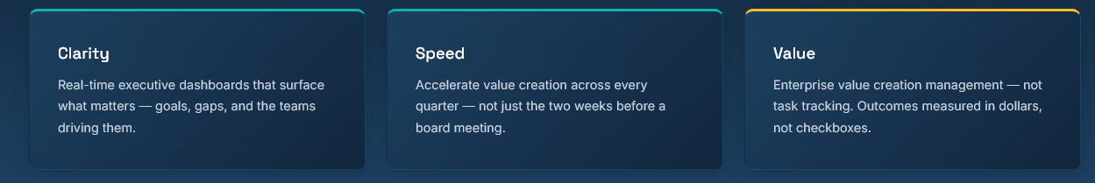

- This text is challenging to read. Can it be brighter and not so faded out?

- The muted text is challenging to read:

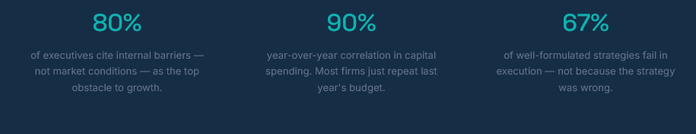
- The pop-up explanations around the “Built for How Leaders Think” graphic image are a nice interactive feature.
  - Is something supposed to happen when the cursor moves over “Strategic View” and “Timeline”? Right now, the cursor becomes a hand, both nothing happens.
  - When I look at it now, the popups don’t work – is this a page loading issue?
- On the “About” page:
  - “Proven Across the Fortune 500” – this text and design is too muted. It makes it look like it is intended to be “off”
  - “The Team Behind the Platform” –Lets go with “Joseph” Thompson.
- On the “Contact” page;
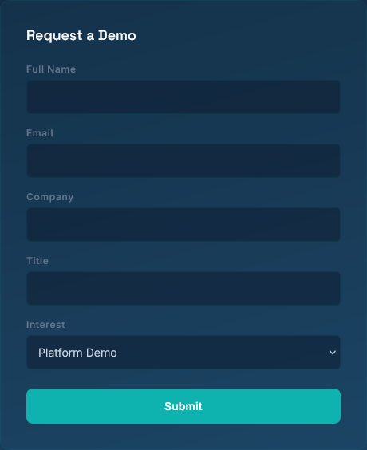
  - Suggest using “Request More Information” instead of “Request a Demo” --since it’s not just a demo that can be requested?
- Some of the options available at the bottom of the page in the menu bar seem to function oddly; they don’t land where expected or go to information that is not directly related to what was clicked
  - “LinkedIn” option goes to the “Contact” page – will this go to a LinkedIn page for Targa?
  - The LinkedIn page needs to match the graphics of the new site.


- There is a tagline at the bottom of each page on the original site – is it worthy of maintaining on the new one?

- Should there be a FAQ page? One exists on the original site
- The original site had several quotes from customers – should those be integrated into the new site? (Testimonials with names/photos)

- Other suggestions:
  - Use Cases / Industries or Resources (Blog, Case Studies, whitepaper)
  - Future suggestion: Different buyers want to see themselves in your product. Create pages such as: “For Healthcare”, “For Small Business”, “For Marketing Teams” -- each could highlight specific problems solved, relevant features, real examples, etc.

